**How to Involve Your Child in Giving Back to Their Community This Holiday Season**

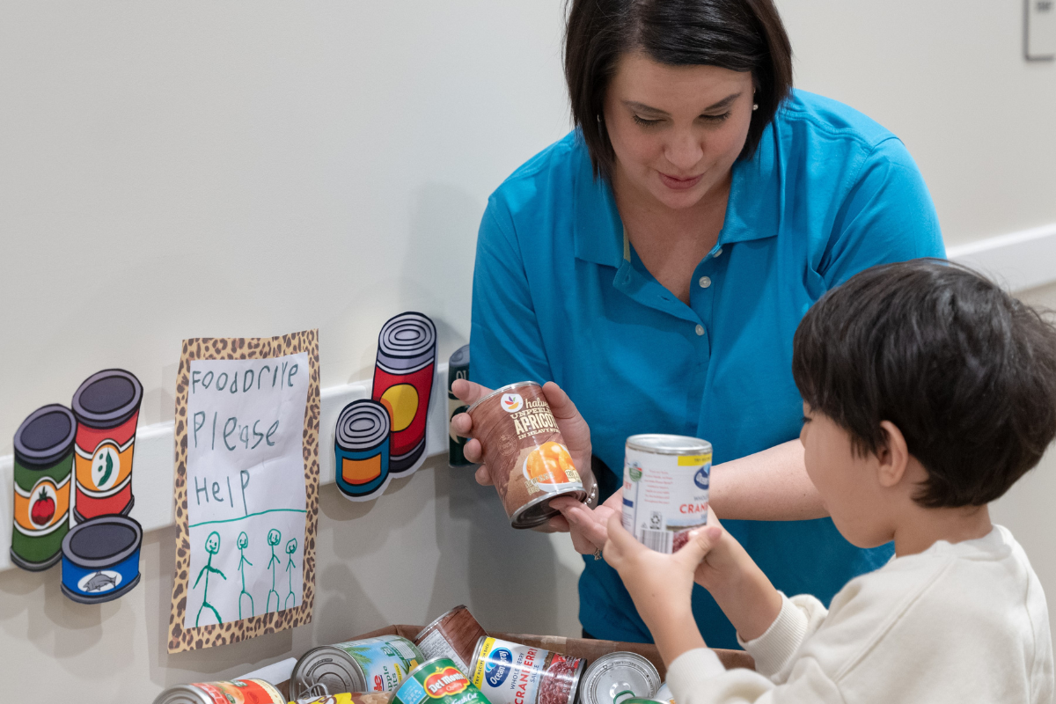

The holiday season is here and one of the best ways to celebrate is by helping others in our community. While it's fun to receive gifts, there's something even more special about giving. Teaching kids to give back during the holidays helps them develop important values like empathy, kindness, and responsibility. That's why we make giving back a priority each year during our Holiday Giving initiative. Our students learn the positive impact they can make and the importance of showing compassion to others. When you involve kids in community service, you're showing them how to make a difference, even at a young age. This holiday season, we’re sharing some family volunteer and gift ideas to help your child give back to their community.

**Create Care Packages for Neighbors**

Preschoolers love to help, so why not get them involved in putting together care packages for your neighbors? You can fill the packages with homemade cookies, warm socks, hot chocolate kits, or decorated pinecones. This hands-on activity will make your child feel proud and connected to the cause.

**Make Holiday Cards for Frontline Workers**

Another great way to give back is by making holiday cards for people who work during the season, like healthcare workers, first responders, and postal workers. Sit down with your child and help them decorate cards or write short notes to thank these essential workers. A simple card from a child can brighten someone’s day and show appreciation for their hard work.

**Donate to Organizations (Toy Drives, Food Drives, etc.)**

One of the easiest ways kids can give back is by donating to a cause. This often just requires a quick trip to the store and a drop-off location. Choose an organization to support, then talk to your child about how they can help. Whether it's selecting food, toys, or blankets, the important thing is to get them involved. Tell them what is needed and bring them along as you shop and deliver donations.

**Volunteer at a Senior Center**

Volunteering at a senior center provides your child with the opportunity to socialize with members of the community and develop empathy. They can sing songs, make crafts, or read books to the residents. Your child will love seeing the smiles they create as they brighten someone's day.

**Help at a Local Food Bank**

You and your child can help by sorting donations or packing boxes. It’s a simple way for kids to understand the importance of providing food for those in need while working as a team with the family.

**Spend Time at an Animal Shelter**

Don't forget our furry friends this holiday season! Volunteering at an animal shelter can be a fun way for your child to give back. Your child can help by organizing pet supplies, folding blankets, or simply spending time with the animals. This teaches kids to care for animals and the importance of kindness toward all living creatures.

**Spread Kindness with Random Acts of Kindness**

Teaching your child that giving doesn’t always require money or big gestures is powerful. Practice small acts of kindness together: hold the door open for others, pick up litter in the park, or give a compliment. Even simple things like sharing a toy or helping with a task can go a long way. Encourage your preschooler to do something kind each day. Celebrate their efforts and point out how even the smallest act of kindness can make a difference.

The holidays are a great time to teach your child about kindness, empathy, and generosity. Helping them give back to others provides your child with lessons that will last a lifetime. To learn more about how we instill these values in our students during the holidays and throughout the year, contact us today!