**October Newsletter**

**A Note from Our Principal**  
As October begins, I’d like to take a moment to appreciate the season’s transition and the exciting opportunities it brings for our students. Autumn provides an ideal setting for learning, with so many changes occurring outdoors and the chance to incorporate new, natural elements into our artwork and learning centers. This month, we have a range of exciting events lined up such as a visit from both the fire department and police department, classroom pumpkin decorating, family scarecrow contest, and Halloween party, parade and trunk or treat. As always, thank you for entrusting us with your child’s education. We’re eager for a season of growth, discovery, and fun.

Sincerely,

Alyssa Caracausa

**Jumpstart’s Read for the Record**

We are excited to again participate in [Jumpstart’s Read for the Record](https://urldefense.com/v3/__https:/www.jstart.org/jumpstarts-read-for-the-record/*:*:text=Over*20the*20course*20of*2019,held*20on*20October*2024*2C*202024.__;I34lJSUlJSUlJSU!!E4z5CuPDl6TP!KPBpUHfNzMZOvwprv_TDeXt6fsUMj8SSq_R1yq-LmpbRH2mbFmL9hsh8Z2ffIpuZbVegxv8xglJToXLs0pwp5e6jgTur42WUEx_m_g$) - the world’s largest shared reading experience that celebrates and supports children’s early language and social-emotional development. Students will participate in activities throughout the week of October 21 inspired by the book, *Piper Chen Sings,*by Phillipa Soo and Maris Pasquale Doran. It is an inspiring story celebrating self-expression, family bonds, and conquering doubts. Keep an eye out for more details in Links to Home!

**Family Referral Bonus & Open House**

Do you know a colleague who has recently had a baby, a friend in need of care who just relocated to the area, or a family member who is seeking a new preschool for their child? Invite them to our Open House Week events on **October 22, 24, and 26**. When you refer a friend and they enroll, you’re eligible for a **free week of tuition**. Ask us for details!

**Fall Cubby Refresh**

The days will soon be getting crisp! Please supply an extra set of weather-appropriate clothes for your child and a jacket for chilly days.

**Alma**

Do you have a different email address or phone number? Need to add or remove an emergency contact? You can do this at any time in Alma. You can also make payments and access statements through the Alma parent portal. If you need help logging in or accessing the system, please let us know.

**New on Our Preschool Blog**

**Important Dates**

October 5 – World Teachers' Day – We will celebrate our teachers on October 4!

October 10-Visit from Chalfont Fire Department 10am

October 14-Visit from New Britan Police

October 22 - Open House 9:30 - 11 AM

October 24 - Open House 6 - 8 PM

October 26 - Open House 10 AM - 12 PM (Touch a Truck event!)

October 31 – Halloween Celebrations and Parade to New Seasons 3:30pm followed by Trunk or Treat. Please join us!

**What Does Kindergarten Readiness Mean?**



If your child is between 3 and 5 years old, you are likely starting to have thoughts about kindergarten and how your child will handle adjusting to this big change. There will be new expectations, new schedules, and many new faces. Will your child adjust to making new friends? Will they be able to stay on task? These days, kindergarten readiness is not just about children being able to write their name or count to 10. Being ready for kindergarten includes various skills and attributes that help your child thrive in a classroom.

This is why our Links to Learning curriculum is designed to not just provide academic support, but focuses on developing the whole child. Below are just a few skills we work on with our students to prepare them for success in kindergarten. We’ve also included some ways for you to support your child’s development at home.

**Social and Emotional Skills**

Knowing how to interact with peers, manage emotions, and take turns are important skills in kindergarten. Our teachers use puppets, books, and problem-solving activities to teach our students how to practice these skills.

At home, work with your child on communicating how they feel and model kindness. Share the importance of engaging in active listening when others are attempting to communicate their emotions, needs, and wants. Read books and ask your child how they think a character feels or what they think about a conflict that occurred within the story.

**Language and Literacy Skills**  
Your child will be prepared for kindergarten if they can follow instructions, express their needs and ideas clearly, and understand basic literacy concepts. In our classrooms, we promote early literacy skills through shared reading experiences, introducing new vocabulary, and using inventive spelling to convey ideas. After shared reading experiences, we ask students to answer questions about the book.

At home, ask your child to “read” signs in your neighborhood, make eye contact while having conversations, and sing songs with you. Early exposure to language and literacy promotes future academic success across all areas of learning.

**Mathematical Thinking Skills**In kindergarten, children will learn basic math concepts and problem-solving skills. Our preschoolers learn the foundations of addition, subtraction, and geometry through hands-on activities and play. They also learn different ways to compare numbers, such as graphs, charts, and grouping of objects. 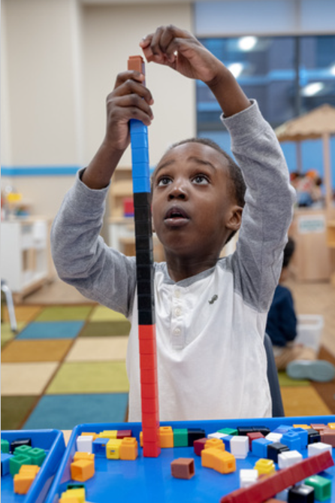

At home, challenge your child to build a structure with a variety of different materials. Ask them to count what they have used and sort their materials by size, shape and color.

**Wellness Skills (Fine & Gross Motor Development)**Our preschoolers learn how to hold a pencil with proper grip, write letter shapes, and cut with scissors. We also practice tasks like zipping coats or tying shoes, enhancing self-help abilities and instilling self-confidence. Children grow their gross motor skills by jumping, throwing, catching a ball and through dancing and movement activities.

While at the park, give your child freedom to test their abilities and take risks. At home, have them practice buttoning and zipping their coats, tying their shoes, and opening food items they will pack in their lunch for kindergarten.

**Fostering Independence and Making Healthy Choices**In kindergarten, children are expected to do self-help tasks independently. In our classrooms, we help our students practice using the restroom and washing their hands. We encourage them to do tasks and make choices on their own before asking for help to foster independence.

Promote independence and healthy choices at home. Give your child simple chores to do or let them help with your daily tasks.

**Celebrating Similarities and Differences**  
Understanding what makes us all unique helps children work collaboratively with peers and develop friendships. Our students learn about their community and the world by sharing experiences and exploring the cultures of others. We promote teamwork as students rotate through learning centers, work with their peers to solve problems, and engage in cooperative play.

One way to reinforce celebrating diversity at home is by exposing your child to books that include a variety of people and cultures. For example, read the book ***My Friend Suhana*** by Shaila Abdullah. Discuss the differences and similarities between the two characters in the book. Allow students to share their thoughts about the story and make connections to their own personal experiences.

Remember that a variety of skills help prepare your child for kindergarten. Each child grows at their own pace and is unique in their own way. We are here to work with you to make sure that your child is not just ready for kindergarten, but for life. To learn more about how our Links to Learning curriculum prepares your child for kindergarten and beyond, contact us/find a school today!