November Newsletter

A Note from Our Principal

From apple and pumpkin-themed activities to leaf hunts and more, we’ve enjoyed all sorts of autumn fun and learning throughout October. This month, we will embark on a journey of fostering connections and celebrating family traditions as we nurture the spirit of Thanksgiving and togetherness. Our students will engage in activities that inspire gratitude and kindness by sharing personal experiences and learning about the importance of giving back to our community.

Thank you for entrusting us with the care and education of your children. We look forward to another month of joy and learning!

Sincerely,

Tiffany Simmons

Holiday Giving

‘Tis the season! Our annual Holiday Giving initiative is a way for students to spread cheer this holiday season while developing an appreciation for what they have, showing gratitude towards others, and seeing the positive impact of their actions. We will be collecting can goods and non-perishable items for the Low Country Food Bank from November 1st – November 18th. This will be a competition between USC Gamecocks and the Clemson Tigers. Lets see what team can collect more cans! More details to come via Links 2 Home. Thank you in advance for your partnership and generosity.

Native American Heritage Month

November is Native American Heritage Month. It is a time to honor their culture, accomplishments, and contributions. When children acknowledge and appreciate diverse cultures, they are helping to build a community of belonging and inclusion. [Insert school-specific information. Ex: We will be celebrating in our classrooms by reading books about Native Americans, making a traditional meal, and exploring nature which is an important part of the Native American culture!]

Thanksgiving/ Fall Celebrations

Our students will be celebrating Thanksgiving with fun classroom activities on November 18th by decorating placemats for our Thanksgiving Feast that will be held on November 25th.

Family Survey Reminder

Our Enrolled Family Survey launched in October. If you have not received the email, please let us know so we can request that it be resent. The survey provides the opportunity for you to give us feedback anonymously on our strengths and areas we can work on. The survey closes November 8.

Family Referral Bonus

Do you know a colleague who has recently had a baby, a friend in need of care who just relocated to the area, or a family member who is seeking a new preschool for their child? When you refer a friend and they enroll, you’re eligible for a free week of tuition. Ask us for details!

Important Dates

November 11 – School CLOSED for Professional Development & Veterans Day

November 12 – Picture Day for Everyone

November 18 – Place Mat Decorating Day

November 20 – World Children’s Day

November 25 – Thanksgiving Feast

November 27 – End-of-month folders go home

November 28-29 – School CLOSED for Thanksgiving

New on Our Preschool Blog

**8 Fun Math Activities for Toddlers**

Introducing toddlers to math concepts through games, songs, and puzzles are just some ways to spark curiosity and make learning about colors, shapes, numbers, and other important math concepts fun. Our Links to Learning curriculum combines learning with play, introducing toddlers to geometry and relationships, problem-solving skills and reasoning, simple counting, shapes, colors, and more through interactive and hands-on activities. Continue the learning at home with these fun games and math activities that will inspire your little ones to discover the magic of math!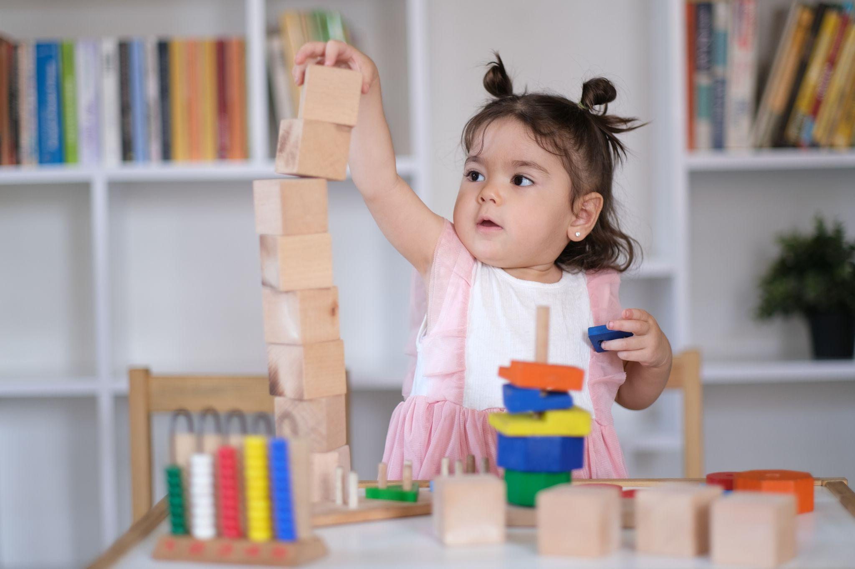

**Colors and Shapes with Cars**

Does your child love playing with cars? Then we have the perfect activity for color recognition and sorting. Supply your child with colored cars and ask them to drive their car to the matching “parking garage.” Your parking garage can be anything from a colored piece of construction paper to a colored bin.

**Puzzles**

Puzzles are a timeless and simple way to help toddlers develop spatial awareness and problem-solving skills. There are shape-sorting puzzles, stacking puzzles, large floor puzzles, and more that are sure to excite and challenge your toddler. Consider getting a number puzzle to begin exploring number recognition. You can even make a puzzle! Print out a picture, cut it into pieces, and ask your child to put them together.

**Hopscotch Number Line**

If your child is in their second year of toddlerhood, this one’s for them! Using chalk, draw a line on your driveway or sidewalk. Draw 1 - 5 short lines intersecting the first line to create a number line and label the numbers. Encourage your child to step or hop along each number, counting as they go.

**Stacking/ Building with Blocks**

Stacking blocks helps toddlers learn about measurement by exploring height and length, improves their spatial reasoning as they fit blocks together, and teaches balance by showing them how to stack without toppling over. Count with your toddler how many blocks they are able to stack. Insider tip: Toddlers love knocking down their block towers! Go ahead and celebrate this fun cause and effect relationship with them, then encourage them to build again!

**Fingerplays and Songs**

Toddlers love to sing and be silly! Do you know “Five Green and Speckled Frogs,” “Sally the Camel,” or “One, Two, Buckle My Shoe”? These are perfect to sing and say with your little ones to help them understand counting concepts as well as begin counting on their fingers. A quick internet search will pull up plenty of resources!

**Water Play!**

Yes, this one’s a bit messy but it’s also so fun and will keep your toddler busy for quite some time. Fill a large bin with water and give your child different types of containers to experiment with volume and measurement by filling and pouring. Discuss concepts like full, empty, and more or less.

*Never leave your child unattended during this activity.

**Counting Nature Walk**

Go on a nature walk collecting items like leaves, stones, flowers, etc. Count them together as you collect or after your walk. Again, discuss more or less, and sort your findings into categories.

**Math Storytime**

It’s likely that you already read books with your child, so why not incorporate math into storytime? There are wonderful books that are fun and teach math concepts. Read “Mouse Paint” by Ellen Walsh to learn about colors, “The Very Hungry Caterpillar” by Eric Carle to teach counting, and “Round Is a Tortilla: A Book of Shapes" by Roseanne Thong to learn about shapes.