Thriving Through Play: Gross-Motor Activities for Growing Preschoolers
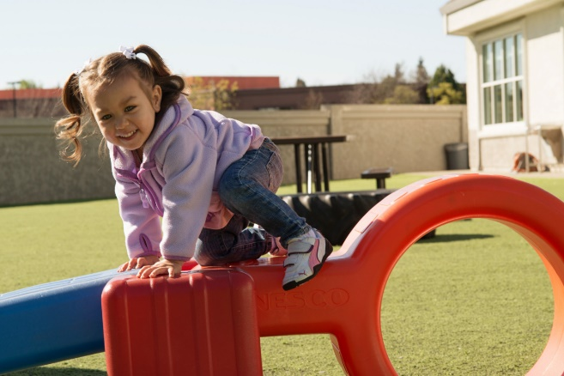
Children grow tremendously from birth through age five, so it is vital that we are there to support them. At our preschool, we help children with balancing skills, hand-eye coordination, and how to stay healthy and safe. It’s all part of our comprehensive Links to Learning curriculum, designed to help every child thrive.
Our dedicated teachers promote wellness through daily learning experiences that encourage children to climb, run, hop, dance, and practice rhythmic movement. Games like Freeze Tag, Simon Says, and Red Light/Green Light help children develop gross motor skills while having a blast!
It’s not all about physical play – we know the importance of building social-emotional skills too. Following directions, teamwork, and taking turns are all part of the fun during our activities. Plus, we also introduce children to basic nutritional and safety concepts, setting them up for a lifetime of healthy choices.
Below, we have compiled a list of age-appropriate outdoor activities that you can do with your child to help continue the development at home.

- Infants (0 – 1 year)
Grass provides a natural and forgiving environment for your infant to explore safely. Take your baby outdoors and allow them to practice movement and balance. Place rattles, soft balls, or textured toys a few feet from your infant, and encourage them to reach and grasp the items.
- Toddlers (1 – 2 years)
Grab a bunch of colorful balls and head outside. Encourage your toddler to roll or kick the balls on various surfaces like soft grass, squishy sand, or smooth pavement. Watch their eyes light up as they discover the different textures and improve their coordination along the way.
- Beginners (2 – 3 years)
Place a few hula hoops on the ground for a series of exciting jumping games. Ask your child to jump from one hoop to the next using both feet. Then, ask them to hop from one to the next on one foot. Lastly, challenge your child to hop from hoop to hoop alternating between their left and right foot.
- Intermediates (3 – 4 years)
Provide your child the opportunity to demonstrate smooth body control through different yoga poses. Lay out a mat, and introduce poses named after animals they are familiar with, such as cat, cow, dog, and frog. Perform the pose first and encourage your child to mimic what they see.
- Pre-K / Pre-K 2 (4 – 5 years)
Use chalk to write various numbers and letters in your driveway. Ask your child to perform a variety of movement by saying phrases such as, “Bear crawl to the letter K” or “Tiptoe to the number 5.” This activity not only fosters gross motor skills, but also encourages letter and number recognition and following directions.

