**Exploring Holiday Traditions from Around the World**

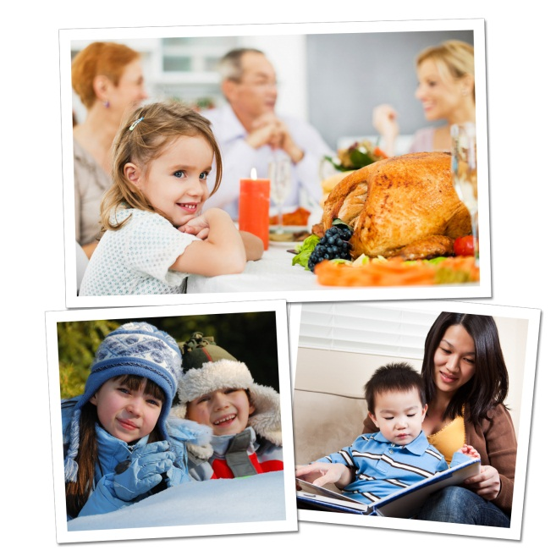The holiday season is here, providing a wealth of opportunities to enrich the children’s understanding of diverse cultures and traditions around the world. In addition, our students will share their own traditions with others.

Below are age appropriate activities that we use in the classroom, as well as activities for you and your child to do at home.

**BEGINNERS (ages 2-3):**

**In the classroom:** As they near the age of two, children begin to recognize the sights and sounds of holidays celebrated by their family.Parents visit our classrooms to share holiday traditions, including unique books, songs and activities.

**At home:** Gather family photos and point out traditions, such as unwrapping presents, eating holiday dinner at grandma’s house, and making a snowman. Encourage your child to talk about what he sees in the photos.

**Recommended reading:** *Children Around the World Celebrate Christmas* by Christine Tangvald, *Happy Hanukkah, Corduroy* by Don Freeman, *My First Kwanzaa* by Karen Katz

**INTERMEDIATES (ages 3-4):**

**In the classroom:** Children sing holiday songs from around the world and are introduced to holiday symbols that they may see in their communities, such as Christmas trees or Hanukkah menorahs.

**At home:** Take a drive with your child or bring him to various holiday festivals in your community. Encourage him to look for and identify holiday decorations.

**Recommended reading:** *Christmas Around the World* by Calliope Glass, *Hanukkah Hop* by Erica Silverman, *Li’l Rabbit’s Kwanzaa* by Donna Washington

**PRE-K/PRE-K2 (ages 4-5)**

**In the classroom:** After learning about holiday traditions around the world, our older preschoolers identify countries on a globe. For example, they might learn about Diwali, the festival of lights, and then find India on the globe. They might make tamales, a dish often served on Christmas, and then find Mexico on the globe.

**At home:** Ask your child to help you prepare your family’s favorite holiday foods. Talk about the long-standing traditions in which these foods are rooted. For instance, you might explain, “I used to bake cookies for the holidays with my mom. Now we can start baking cookies together!”

**Recommended reading:** *Children Just Like Me: Celebrations* by Anabel Kindersley, *Light the Lights: A Story about Celebrating Hanukkah and Christmas* by Margaret Moorman, *The Story of Kwanzaa* by Mary Washington

Exposing children to various holiday traditions helps them build strong social skills, establish a sense of self, and respect the differences of others as they transition into elementary school and beyond.

- Lauren Starnes, PhD – Director of Early Childhood Education