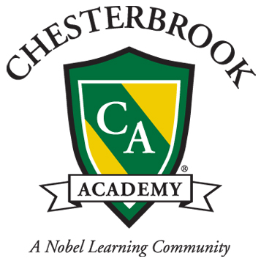

Uniform Policy

UNIFORMS
Our students wear a school uniform on a daily basis. This policy must be adhered to so that our student body develops a feeling of community, belonging, and school ownership. The requirements change based on whether it is an academic day, a PE day, or a formal day. There are also options, based on weather/season.
Academic Uniform, Boys
Navy or khaki twill walking shorts or long pants (No cargo pants/multiple pockets)
Chesterbrook Academy logo Polo shirt, long or short sleeves, in navy, forest green, or white.
Chesterbrook Academy logo navy sweatshirt or plain colored sweatshirt (no pictures or words or logos) in navy, forest green, or white.
Navy, brown, or black closed toe shoes; tennis-shoes are acceptable but not sandals or clogs.

Academic Uniform, Girls
Chesterbrook plaid drop-waist jumper or plaid wrap-around kilt
White Peter Pan collared blouse
Navy or khaki skort, twill shorts, or long pants (No cargo pants/multiple pockets)
Chesterbrook Academy logo Polo shirt, long or short sleeves, in navy, forest green, or white.
White or navy socks or tights; no patterns or prints.
Chesterbrook Academy logo navy sweatshirt or plain colored sweatshirt (no pictures or words or logos) in navy, forest green, or white.
Navy, brown, or black closed-toe and closed-heel shoes; tennis shoes are acceptable, but not sandals or clogs.

PE Uniform, Boys and Girls
This uniform is to be worn to school by Junior K through 2nd grade students on their PE days (twice a week). 3rd-6th grade students must bring their PE uniform with them to school and change when their class is scheduled.
Navy or white Chesterbrook Academy logo t-shirt, long or short sleeved
Navy mesh shorts with Chesterbrook logo
Navy Chesterbrook logo sweatshirt and sweatpants
Socks
Black or white sneakers that tie or Velcro; no slip-on shoes

Formal Uniform
There will be several Formal Days throughout the month.
Boys:
Khaki twill long pants (No cargo pants)
White button-down Oxford shirt
Chesterbrook plaid tie
Navy Chesterbrook Academy logo v-neck or cardigan sweater
Black or brown dress shoes; dark socks

Girls, Junior K through Third Grade:
Chesterbrook plaid drop-waist jumper
White Peter Pan collared blouse
Navy Chesterbrook Academy logo cardigan sweater
White or navy tights
Closed-toe and heel navy or black dress shoe

Girls, Fourth-Sixth Grade:
Chesterbrook plaid drop-waist jumper or wrap-around kilt
White Peter Pan collared blouse
Navy Chesterbrook Academy logo cardigan sweater
White or navy tights or nude pantyhose
Closed-toe and heel navy or black dress shoe

Sometimes during the year a student may feel chilled in the classroom and wish to wear a sweater or hoodie zippered sweat jacket. For these times, they should wear either their Chesterbrook Cardigan or v-neck sweater or purchase a chesterbrook logo navy blue hoodie.

If you have any questions, please don’t hesitate to call us at 703-404-0202.

